Forum: Environment Commission
Issue: Addressing the challenges of promoting sustainable fisheries and exploring ways to reduce overfishing and promote sustainable fishing practices especially in African coastal regions
Student Officer: A Jin Chang
Position: President

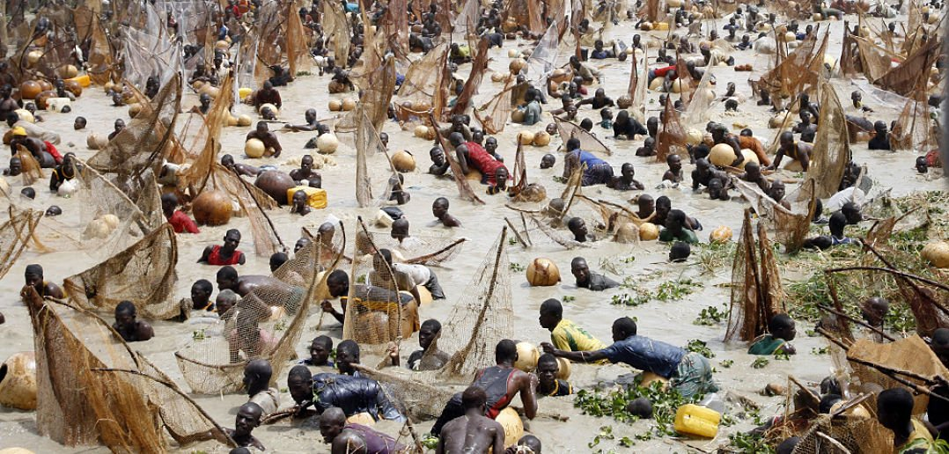
Introduction
Figure 1: Photo of IUU fishing in West Africa
African coastal regions serve as an essential source of livelihood for millions; however, they are facing the challenge of overfishing and a lack of sustainability in fishing. According to the Food and Agriculture Organization of the United Nations, 'the number of overfished stocks globally has tripled in half a century, and today 1/3 of the world’s assessed fisheries are pushed way beyond their biological limits.' The main cause of overfishing is illegal, unregulated, and unreported (IUU) fishing. Especially in African coastal regions, there are no strong regulations regarding the issue of overfishing, making people easily involved in IUU fishing. Another factor contributing to overfishing is the lack of people’s understanding of the side effects of overfishing. Since fish play a significant role in the marine ecosystem, the mass removal of fishes from the ocean would cause a great imbalance in the entire marine food web. Although the problem of overfishing may not seem relevant to humanity, it has detrimental impacts on even the communities that rely on fish resources. For instance, overfishing may devastate local economies dependent on the fishing industry. African coastal countries such as Egypt, Nigeria, Morocco, and South Africa are highly dependent on the fishing industry. However, as fish stocks decline due to overfishing, this would lead to reduced profits for fishermen and even unemployment. For countries that have a large proportion of their GDP from the fishing sector, overfishing can have a negative impact on their economic growth. The situation of overfishing in Africa is worsening due to the lack of sustainable fishing practices that cause IUU fishing. If this problem continues, there will be deadly consequences. Therefore, it is crucial for the Environment Commission to devise effective and pertinent solutions that will help promote sustainable fishing practices in African coastal regions to overcome the challenge of overfishing.

Definition of Key Terms

Overfishing
Overfishing is fishing beyond a sustainable level, which is caused by harvesting too many fish of a particular species at once to the extent the breeding stock left will not be enough to replenish themselves.

Fisheries
Fisheries refer to a place where fish are reared for commercial practices.
Sustainability
Sustainability refers to the ability to maintain support a process continuously over time. In the context of sustainable fishing, sustainability seeks to prevent depletion of fish resources to maintain an ecological balance.

African Coastal Regions
African Coastal Regions refer to areas along the continent’s coastline, which borders the Atlantic Ocean. In Africa, there are 38 coastal and island states.
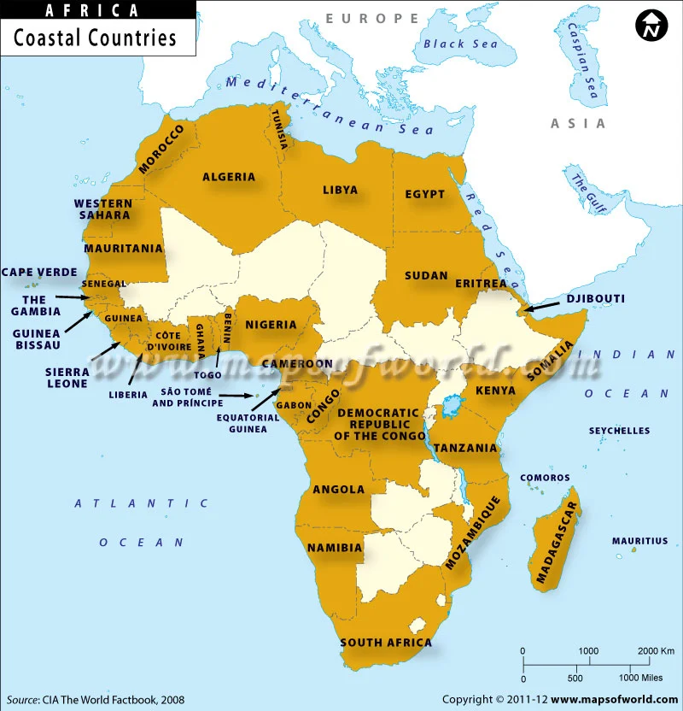
Figure 2: Diagram showing African Coastal Regions

Illegal, Unregulated, Unreported (IUU) Fishing
IUU fishing is a broad term which is used to capture a wide variety of fishing activities. Illegal fishing is fishing without the permission of that State or can be violating the laws and regulations set by the government. Unreported fishing includes which have been not reported or misreported. Unregulated fishing is there is no management measures for fish stocks.

Gross Domestic Product (GDP)
Gross Domestic Product refers to the total value of all finished goods and services produced within a country’s borders in a specific period of time.

Fishing Industry
Fishing Industry includes any industrial activities that takes, processes, stores, markets seafood from oceans, rivers, and lakes.

Background

History of Overfishing
The start of overfishing dates back to the early 1800s when humans were fishing whales to extract blubber for lamp oil. Overfishing increased drastically, leading to the extinction of Atlantic cod, herring, and California’s sardines by the mid-1900s. By 2003, industrial fishing had reduced the number of fish in the ocean by 10% of the population before overfishing started in the 1800s. Finally, in 2009, the US government recognized the severity of overfishing. Hence, the Federal Ocean Acidification Research and Monitoring Act provided opportunities for interdisciplinary research and long-term monitoring to mitigate the impacts of overfishing. However, according to The Census of Marine Life, a decade-long international survey completed in 2010, it was announced that 90% of the big fish had already disappeared in the world’s oceans due to overfishing. It is predicted that by 2050, the global fishing industry will collapse. This will be a threat not only to global food security but also to biodiversity.

Causes of Overfishing in Africa

Poor Fisheries Management
One of the major causes of overfishing in Africa is poor fisheries management. Although some trawlers are licensed, most operate illegally, as licensed fishermen are required to pay taxes. Moreover, many governments in African coastal states lack the ability to monitor illegal, unregulated, and unreported (IUU) fishing, set fair taxes for fishermen, and even collect revenue from the fishing industry. Mr. Bangura, the Minister of the Republic of Sierra Leone, claims that the fishing industry does not bring in a lot of revenue compared to other sectors such as agriculture. Therefore, the government tends to focus on other economic sectors, leading to the fishing industry being more unregulated. Unlike other regions of the world that have the capacity and technology to detect and monitor IUU fishing, African coastal regions lack strict regulations and practices, limiting their ability for sustainable fishing.

Economic Aspects
Another major cause of overfishing in Africa is the increasing demand for fish. Due to its affordability, accessibility, and nutritional value, fish is highly sought after as a food source. Reports from the Blue Food Assessment suggest that global fish consumption will increase from 80 million tonnes to approximately 155 million tonnes by 2050. To meet the demands of the growing population, this puts pressure on the fishing industry to continue fishing to an extent that exceeds biological limits. As a result, fish is ranked as one of the most highly traded foods, fueling a $362 billion global industry. Furthermore, as discussed in the introduction, many African coastal countries such as Egypt, Nigeria, Morocco, and South Africa are highly dependent on the fishing industry. For these countries, fishing is a primary source of income and livelihood. It is also a job that is accessible to many people, leading to an influx of individuals into the fishing sector and contributing to overfishing.

Consequences of Overfishing

Exhausted Fish Stocks and Ecosystem Imbalance
The consequences of overfishing are often disregarded. One of the most devastating impacts is the exhaustion of fish stocks, leading to an imbalance in the ecosystem. The UN Food and Agriculture Organization (FAO) has announced that approximately 70% of the fish population is fully used, overused, or in crisis. As the marine ecosystem consists of various species, the disappearance of even one species beyond a certain level can have a profound impact on the entire food web. For example, vulnerable species such as sea turtles, oceanic sharks, and ray species are affected by the loss of fish populations, causing an imbalance in predator-prey relationships. Unfortunately, coral reefs are also being damaged by overfishing, as they support diverse marine species, participate in nutrient cycling, and provide habitats for fish species. Moreover, if the marine ecosystem collapses, there will be other consequences related to a reduction in ecosystem resilience. A balanced and diverse marine ecosystem helps prevent and withstand climate change; however, when there is an imbalance between species, the ecosystem becomes more vulnerable to these negative natural events.

Economic Losses and Social Impacts
When fish populations continue to decline to the extent that they are not able to replenish their population, it will cause a tremendous economic effect on the countries that rely on the fishing sector. The Environmental Defense Fund claims that 'overfishing is bad for fish, but worse for the economy.' If there are fewer fish stocks to catch, this would lead to reduced opportunities in fishing, and the size of the fishing industry would shrink. As mentioned in another section of the chair report, African coastal states heavily rely on the fishing industry as a source of income. Therefore, continued overfishing will ultimately result in challenges such as unemployment and a lowered level of GDP. The social impact of overfishing is increased food insecurity. Fish are known to support half the world’s population as a major source of protein. As fish stocks decline, Less Economically Developed Countries (LEDCs) would have to suffer from an increased cost of fish, making it more difficult for low-income households to afford a nutritious diet. Hence, there are various consequences that overfishing brings globally.

Major Parties Involved

African Union (AU)
The African Union (AU) is a continental organization which consists of 55 member states in Africa. The AU was established in 2001 to promote unity and solidarity of African countries. The AU aims harmonize member states’ policies. Even more, they set regulations and policies on setting marine protected areas and attempt to implement sustainable fishing practices.

United Nations Food and Agriculture Organizations (UN FAO)
Food and Agriculture Organizations (UN FAO) is a specialized agency of the United Nations (UN) that aims to improve nutrition and food security for global population. The UN FAO was founded in 1945, and there are multiple conferences held each year regarding the food security of the world. FAO recognizes the severity of overfishing and tries to address this challenge through research and data collection of fish stocks, help to develop policies, and even promote sustainable fishing practices.

Oceana
Oceana is a nonprofit ocean conservation organization founded in 2001 that aims to campaign around the globe and restore the world’s ocean. The main purpose of Oceana is to preserve marine ecosystem; therefore, they highly recognize the severity of overfishing. They often work with various member state governments and policymakers to implement sustainable policies for fisheries management, and combat IUU fishing.

Previous Attempts to Resolve the Issue
To reduce overfishing and promote sustainable fishing practices, the UN and NGOs are encouraging the member states to do so. The first legislation regarding the issue of overfishing was established in 1976 by the United States government. The Magnuson-Stevens Fishery Conservation and Management Act first introduced fishery management that includes regulations on catch limits and dealing with overfished stocks. Other countries started to adapt to different fisheries management policies once the issue of overfishing started to be more recognized. In 1991, Australia started restricting certain fishing gears, such as cast nets, crab traps, drum nets, and many more to prevent overfishing. Moreover, by 2004, the North Sea Cod Recovery Plan was led by the European Union (EU) to rebuild the depleted cod stocks. It was the first policy that set temporary closures in spawning areas of North Sea Cod. By 2005, most of the More Economically Developed Countries (MEDCs) have set strict regulations to prevent IUU and overfishing and promote sustainable fishing practices. Finally, by 2008, West Africa has adapted West African Fisheries Program (WARFP), supported by the World Bank. Countries such as Senegal, Gambia, Sierra Leone were some of the first African countries that were involved in the WARFP to carry out sustainable fishing practices, such as limiting catching numbers of fish and enhancing governance structures. Some specific examples of regional cooperation include conducting monitoring and evaluation of Program investments, and share information and results throughout the region, implement communication activities to increase public awareness about the WARFP program and implementation progress, and coordination of regional procurement. Furthermore, since African countries lack the capacity for fisheries management, the World Bank has funded the countries to provide more access to Proactive trade information system (PTIS) and analysis for the government to make better decisions in fisheries management. Moreover, the World Bank helped to fund in advanced technology such as satellite-based vessel monitoring system (VMS) to prevent IUU fishing. These West African countries continue to work for sustainable fishing practices. After 2008, more and more African coastal states have joined to implement sustainable fishing practices. For instance, Ghana, Senegal, Kenya has established new Marine Protected Area (MPA) to conserve biodiversity. However, it is hard to evaluate the effectiveness of these practices, due to the nature of IUU fishing. IUU fishing cannot be monitored easily, and the rate of overfishing has increased throughout the decades due to high demands for fish, this makes people question the effectiveness of these sustainable practices.
Besides African countries, the UN is highly aware of the issue of overfishing, therefore has made multiple attempts to combat the issue. In December 2020, member states of UN have gathered and formed a resolution on adopting sustainable fisheries. The UN also created an international day against IUU fishing, which is June 5th. By setting an international day, UN hopes to bring the public and the fishing industries attention to the severity of IUU fishing. To have a further look into the resolution and events, refer to the bullet point list below:
- General Assembly Adopts Resolution Regarding Sustainable Fisheries, Postpones Action on Law of Sea Convention, Awaiting Input Concerning Text’s Budget Implications (GA/12297)
- International Day against IUU Fishing, June 5th (https://www.un.org/en/observances/end-illegal-fishing-day)

Possible Solutions
- The first possible solution to address the challenges of promoting sustainable fisheries and exploring ways to reduce overfishing especially in African coastal regions can be to implement policies for fisheries management. Although many countries already implemented policies for sustainable fishing practices, they are not emphasized enough, especially in African countries. To prevent IUU fishing, heavier fines and punishment for fishermen when caught IUU fishing can be an effective way for people to be licensed to fish. Once they are licensed to fish, it would be easier for the government to monitor their fishing and prevent actions that regulate the existing polices on fishing.
- Another possible solution is to expand and build on capacity. Since African coastal states lack the ability to carry out training and educational programs, they can receive support from World Bank, or NGOs such as Oceana to enforce and engage sustainable fishing practices. This would include encouraging fishermen to use other types of fishing tools to prevent overfishing, severity of IUU, raising awareness of MPAs etc.
- Moreover, African coastal states can utilize technological advancements to monitor fishermen and attempts to overfish. Satellite monitoring, electronic vessel monitoring system, and blockchain technology will be effective to detect IUU fishing. Again, this would also require high cost, therefore it would be an effective solution if other organizations or member states support the countries to do so.
- The last possible solution is to raise public awareness. Because the issue of overfishing is under looked, and countries may have cooperation’s with NGOs to promote the severity of overfishing. The topic of overfishing can be part of the compulsory education, so that the public is aware about the choices of food they make as a consumer, and the consequences it may follow, such as marine ecosystem imbalance and increased food insecurity.

Bibliography
“Decreasing Fish Stocks.” WWF, <wwf.panda.org/discover/knowledge_hub/endangered_species/cetaceans/threats/fishstocks/>.
“Fao.Org.” What Is IUU Fishing? | Illegal, Unreported and Unregulated (IUU) Fishing | Food and Agriculture Organization of the United Nations, <www.fao.org/iuu-fishing/background/what-is-iuu-fishing/en/>.
“General Assembly Adopts Resolution Regarding Sustainable Fisheries, Postpones Action on Law of Sea Convention, Awaiting Input Concerning Text’s Budget Implications | UN Press.” United Nations, United Nations, <press.un.org/en/2020/ga12297.doc.htm>.
Ifesinachi Okafor-Yarwood Lecturer. “African Countries Must Protect Their Fish Stocks from the European Union - Here’s How.” The Conversation, 24 July 2023, <theconversation.com/african-countries-must-protect-their-fish-stocks-from-the-european-union-heres-how-177095?>.
“International Day Against Illegal Fishing.” United Nations, United Nations, <www.un.org/en/observances/end-illegal-fishing-day>.
“Overfishing Destroying Livelihoods | Africa Renewal.” United Nations, United Nations, <www.un.org/africarenewal/magazine/may-july-2017/overfishing-destroying-livelihoods>.
“Overfishing.” Australia & New Zealand - English, <http://www.msc.org/en-au/what-we-are-doing/oceans-at-risk/overfishingwww.msc.org/en-au/what-we-are-doing/oceans-at-risk/overfishing>.
“Overfishing: The Most Serious Threat to Our Oceans.” Environmental Defense Fund, <www.edf.org/oceans/overfishing-most-serious-threat-our-oceans>.
Payne, Emily, et al. “24 Groups Working towards a More Resilient Fishing Industry.” Food Tank, 23 Nov. 2020, <foodtank.com/news/2020/11/organizations-supporting-sustainable-fishing/>.
“Report: Overfishing Bad for Fish, but Worse for the Economy.” Environmental Defense Fund, <www.edf.org/blog/2014/04/02/report-overfishing-bad-fish-worse-economy>.
“Rising Sea Levels Besieging Africa’s Booming Coastal Cities - World.” ReliefWeb, 24 Nov. 2022, <reliefweb.int/report/world/rising-sea-levels-besieging-africas-booming-coastal-cities>.
“Sub Regional Fisheries Commission.” Spcsrp, spcsrp.org/en/west-africa-regional-fisheries-program warfp.
“The Survival of Marine Fauna Depends on Sustainable Fishing.” Iberdrola, Iberdrola, 22 Apr. 2021, <www.iberdrola.com/social-commitment/sustainable-fishing#:~:text=Sustainable%20fishing%20respects%20marine%20ecosystems,the%20survival%20of%20all%20species.&text=Sustainable%20fishing%20rejects%20the%20indiscriminate,or%20those%20without%20commercial%20val>.
“What Is Overfishing.” MSC International - English, <www.msc.org/what-we-are-doing/oceans-at-risk/overfishing>.
“What Is Overfishing? Facts, Effects and Overfishing Solutions.” WWF, World Wildlife Fund, <www.worldwildlife.org/threats/overfishing#:~:text=It%20can%20change%20the%20size,like%20sea%20turtles%20and%20corals>.
“What We Do.” Oceana, 6 Dec. 2023, <oceana.org/about/#:~:text=Oceana%20is%20campaigning%20around%20the,us%20as%20they%20are%20vast.>

Appendix or Appendices
- https://www.un.org/africarenewal/magazine/may-july-2017/overfishing-destroying-livelihoods (UN Article on Overfishing Destroying livelihoods)
This website contains general information on the topic of overfishing, focusing on African waters. It is a great website to get you started researching.
- https://www.fao.org/iuu-fishing/background/what-is-iuu-fishing/en/ (IUU Fishing)
If you would like to find out more information on the topic of IUU fishing, this is a helpful website to deepen your understanding on the topic. This source is reliable since it was created by the FAO, furthermore, contains hyperlinks that take to other sources regarding the issue of IUU fishing and fishery management in general.
- https://press.un.org/en/2020/ga12297.doc.htm (General Assembly Resolution regarding sustainable fisheries)
This website contains information on the Resolution that was published in 2020 regarding sustainable fishery management. Because there are some information on how different countries view this topic, it will be beneficial if you check if you can find any information on how your delegation views this issue.
- http://spcsrp.org/en/west-africa-regional-fisheries-program-warfp (West Africa Regional Fisheries Program)
This website will be helpful when writing a resolution, because it contains variety of approaches West African countries are taking for sustainable fishery management.

